  - Name: Soniya Eknath Girhe. Sec_Batch_RollNo.: A7_B3_59.
  - Date: 17/02/2026.

Practical 01

Aim
To study and implement time manipulation using object-oriented programming in Java,
and to understand the concept of extending functionality using inheritance without
modifying existing classes.

Code:
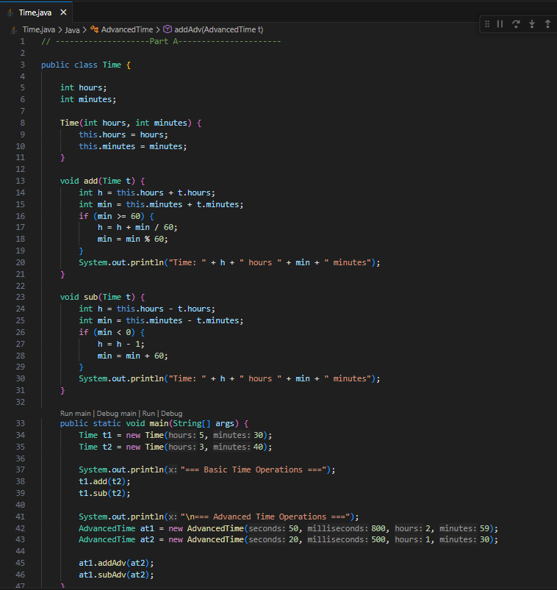
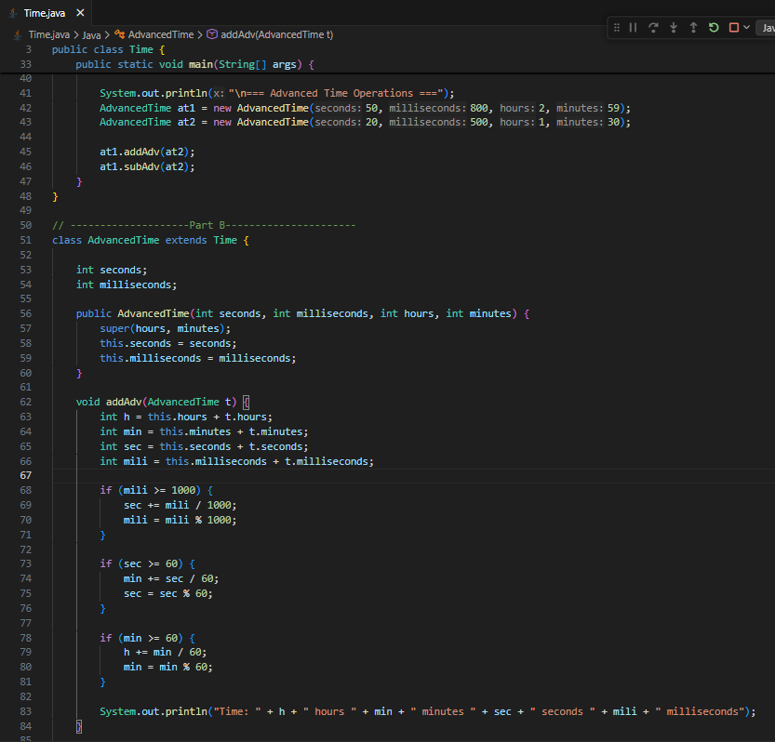
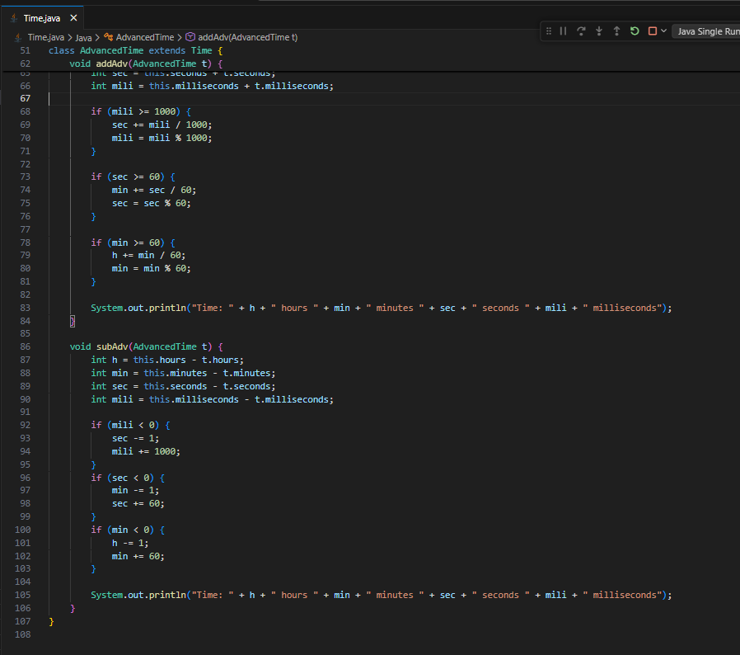

Output:
